Use-Case Realization Report
UpdateUserAdministrator

Issue <1.0>
Revision History
Date | Issue | Description | Author
<02/08/09> | <1.0> | <Update User Administrator> | <Karen Gao>

Table of Contents
1. Brief Description 4
2. Flow of Events 4
3. Interaction Diagrams 4
3.1 Collaboration Diagram for UpdateUserAdministrator 4
4. Participating Objects 4
5. Class Diagrams 5
5.1 Class Diagram for UpdateUserAdministrator 5
6. Derived Requirements 5

Use-Case Realization Report
UpdateUserAdministrator

Brief Description
The update of User Administrator shall be executed once the check for the selection of the existing UserAdmin list and validation of updates were performed.

Flow of Events

Standard Flow
This use case covers the events of updating UserAdmin, which is part of the Maintenance UserAdmin package. The standard flow of events is described as below:
- The Portal Administrator shall press the button to send out a command of “updateButtonClicked” on the interface of UserAdminPage.
- Once UserAdminController received this request, the operation checkUserAdminToUpdate will check if there’s UserAdmin seleted.
- Then the operation getRole will get the Role from object of Role, and show to the UserAdminPage through the operation displayUserAdmin.
- The Portal Administrator shall press the button of updateSaved to UserAdmin Controller, and it will check for the validation of updates.
- Subsequently, role will be re-assigned to the customer through the operation reassignRole of UserAdmin Controller. The operation updateUserAdmin will sent the updated UserAdmin in the UserAdmin List from object of UserAdmin.
- Once it’s done, the successful updating UserAdmin will show to the UserAdminPage through the operation showUserAdminList.

Exceptions

- If there’s no selection found in UserAdmin records, a warning message will be show to the UserAdminPage through the operation showNoUserAdminSelectedMsg.
- If there’s invalidation found, a warning message will be show to UserAdminPage through the operation showUpdatesInvalidMsg

Interaction Diagrams

Collaboration Diagram for UpdateUserAdministrator
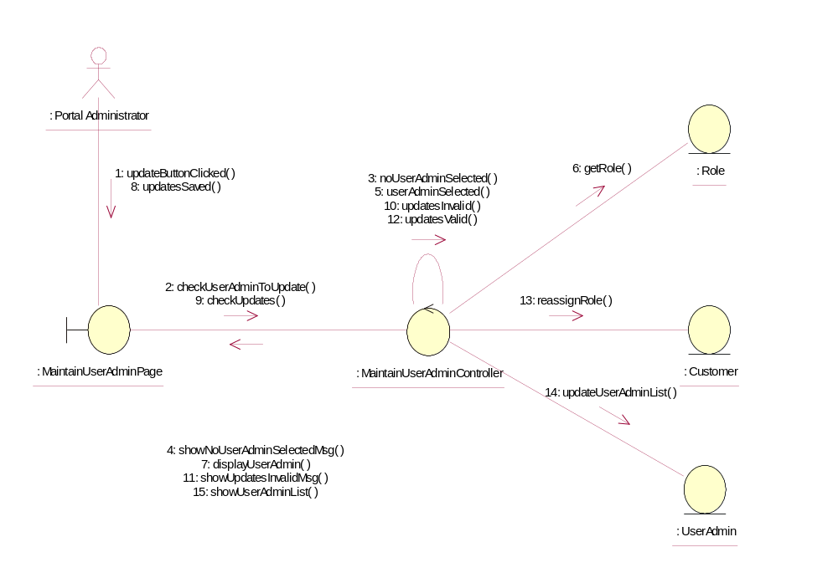

Participating Objects
: Customer
This Entity is Customer object

: MaintainUserAdminController
This controller is to add, delete and update User Admin

: MaintainUserAdminPage
This is a page for adding, deleting, updating and displaying User Admin

: Portal Administrator
This is the super user of the system

: Role
This Entity is Role object

: UserAdmin

This Entity is User Admin object

Class Diagrams

Class Diagram for UpdateUserAdministrator
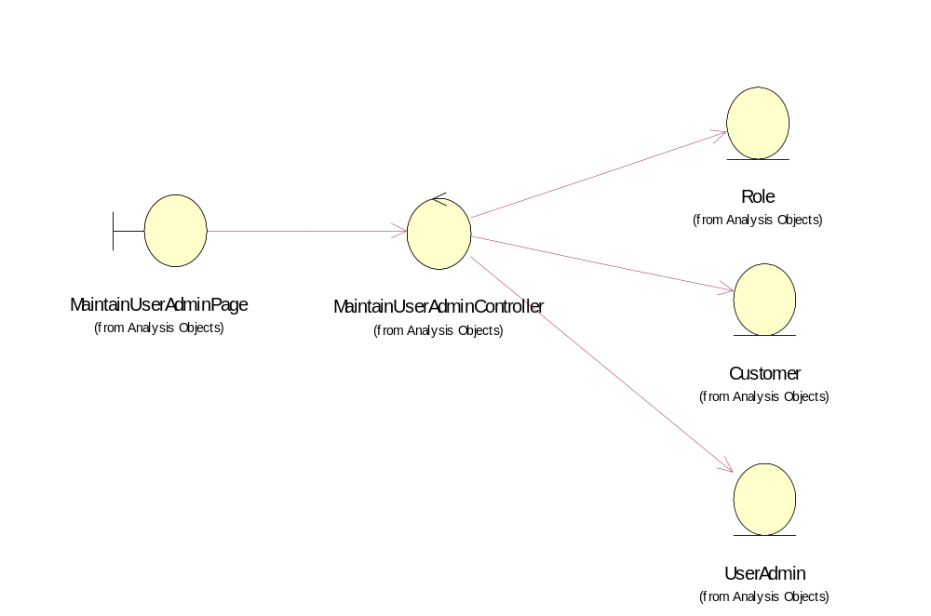

Derived Requirements
Only Portal Administrator has rights to access this page.

